**Letter of credit request**

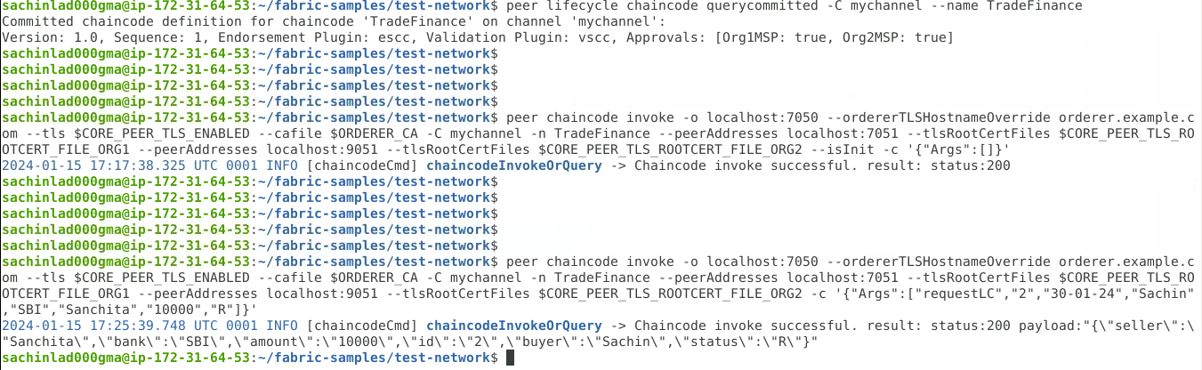

**Letter of credit Issued**



**Letter of credit Accepted**



**View Letter of credit**

